iCoat-320 Coating Thickness Gauge
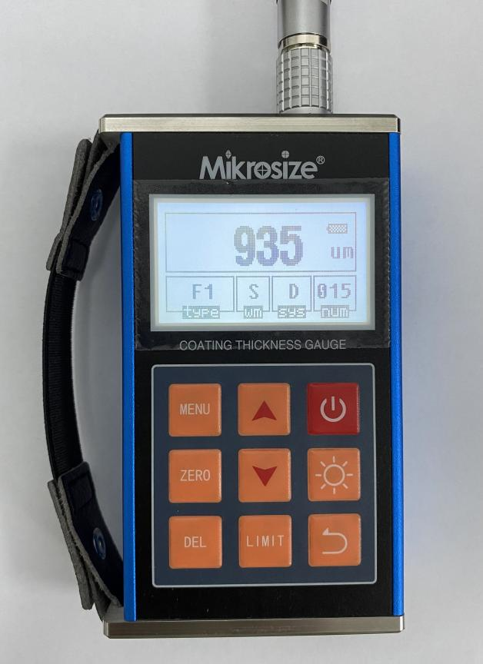
文件名：主机测量结果

Product Features and Application
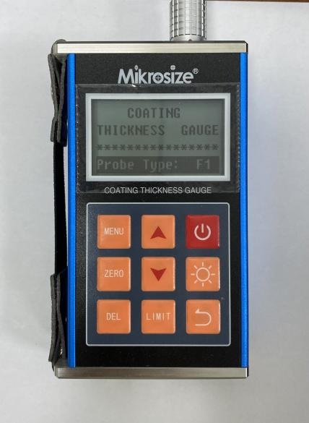  图片文件名：开机界面  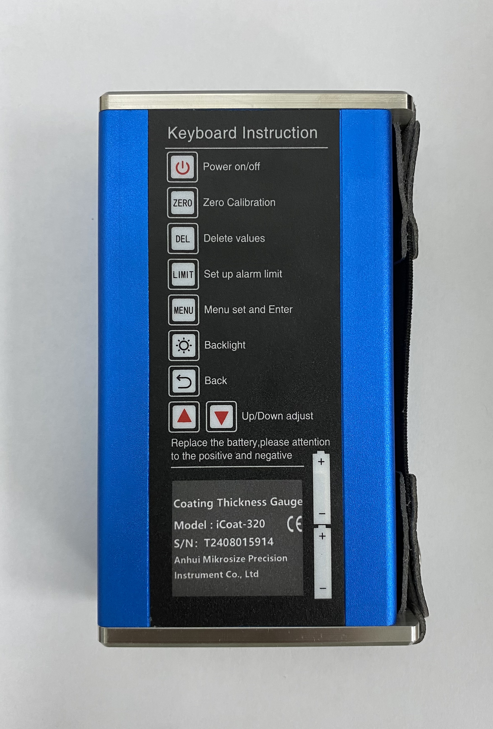  图片文件名：背面  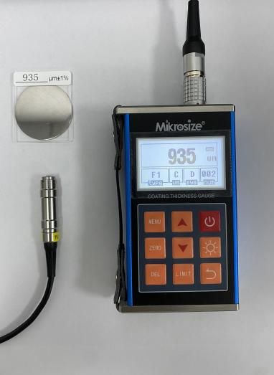  图片文件名：整体 | Product Features:  - Employs both magnetic and eddy current thickness measurement methods, allowing for the measurement of non-magnetic coating thickness on magnetic metal substrates as well as non-conductive coating thickness on non-magnetic metal substrates.  - Compatible with 10 types of probes (F400, F1, F1/90°, F5, F10, N400, N1, N1/90°, CN02, N10).  - Offers two measurement modes: Continuous (CONTINUE) and Single (SINGLE)  - Provides two operation modes: Direct (DIRECT) and Group (APPL1-5)  - Includes five statistical parameters: Mean (MEAN), Maximum (MAX), Minimum (MIN), Number of Tests (NO.), and Standard Deviation (S.DEV)  - Capable of calibration using both single-point and two-point calibration methods, with the ability to correct systematic errors of probes through basic calibration.  - Storage function: Can store up to 495 measurement values.  - Deletion function: Allows for the deletion of individual suspicious data during measurement or all data in the storage area for new measurements.  - Limit setting: Automatically alerts for measurements outside the set limits.  - Power undervoltage indication function.  - Audible beeps for operational prompts.  - Error indication function, displaying errors on the screen or through audible beeps.  - Two shutdown modes: Manual and automatic.  - The main unit can be connected to a computer via installed software, enabling convenient data download, storage, and printing functions through computer operation.  - Comes with a strap for easy one-handed carrying and to prevent dropping.  Product Application:  - Widely used in various inspection fields such as manufacturing, metal processing, chemical industry, and commodity inspection.

Operation Interface
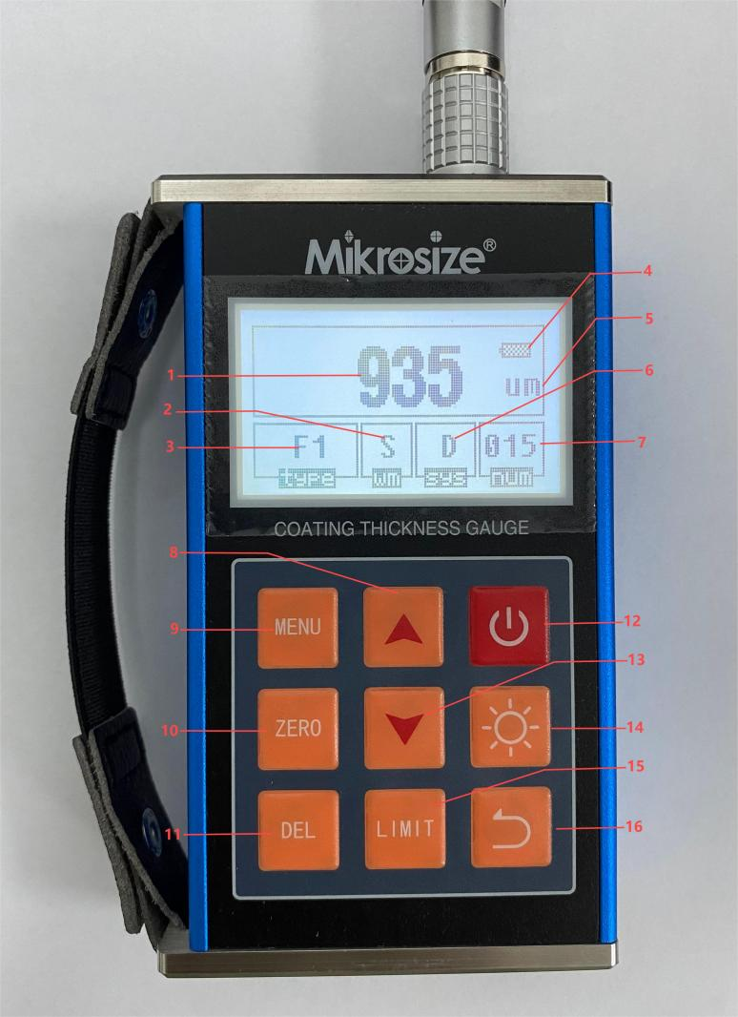
图片文件名：主机测量结果
1.Data Display 2.Measurement Mode 3.Probe Type Indicator
4.Battery Level Display 5.Measurement Unit 6.Working Mode
7.Storage Record Technical Indicator 8.Up Arrow Key
9.Menu Key 10.Zero Calibration Key 11.Delete Key
12.Power On/Off Key 13.Down Arrow Key 14.Backlight Key
15.Set Limit Key 16.Return Key

The boundary can only be set in the group working mode.
The screen is clear and the interface layout is reasonable, so users can quickly find the information they need.

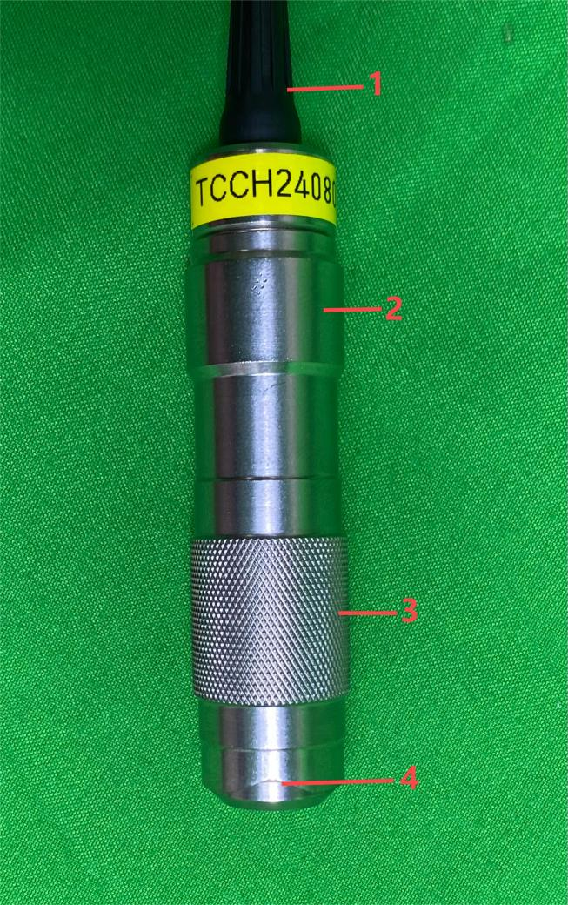
Probe
1.Connection cable
2.Loading sleeve
3.Positioning sleeve
4.V-shaped groove

图片文件名：探头

Setting Interface
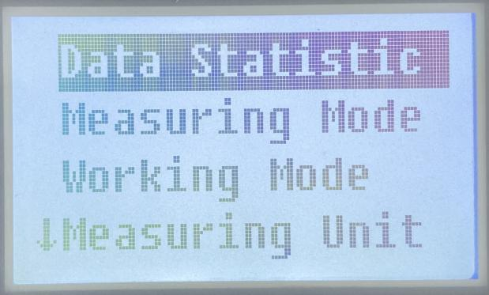  图片文件名：设置数据统计 | ●Date Statistic  Calculate the total number, Average, Maximum, Minimum, And Standard Deviation Of Statistical Samples  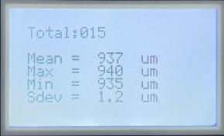  图片文件名：数据统计
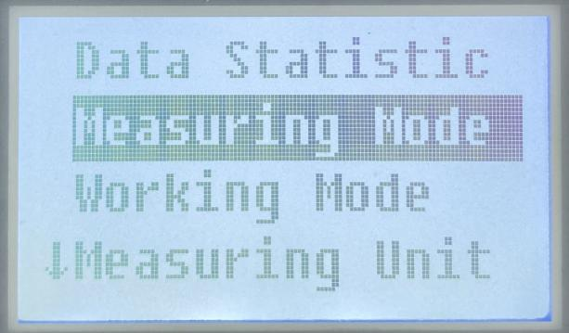  图片文件名：设置测量方式 | ●Measuring Mode  Two measurement modes can be selected  Single (Single Measurement): The probe will display one measurement result with a beep sound each time it touches the tested object  Continue (Continuous Measurement): Measure dynamically without lifting the probe. There will be no beep sound during the measurement process, and the measurement results will flash on the screen.
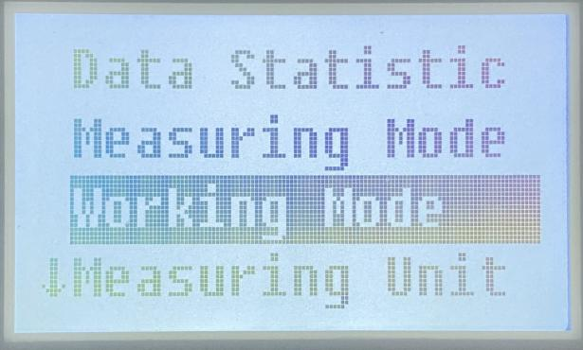  图片文件名：设置工作模式 | ●Working Mode(工作方式)  Two working modes can be selected  DIRECT (direct mode): This mode is used for casual measurement, and the measured value is temporarily stored in the memory unit.  APPL1-5 (grouped mode): This mode facilitates users to record the tested data in batches. Up to 99 values can be stored in one group, with a total of five groups, allowing for a total of 495 values to be stored.
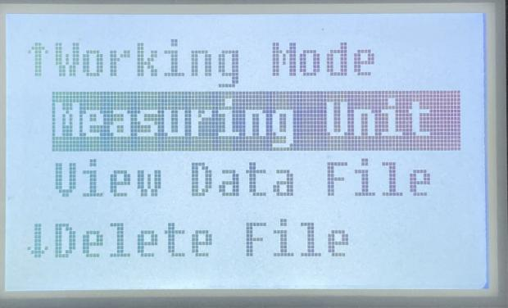  图片文件名：设置测量单位 | ●Measuring Unit  μm (metric system) / mils (imperial system)
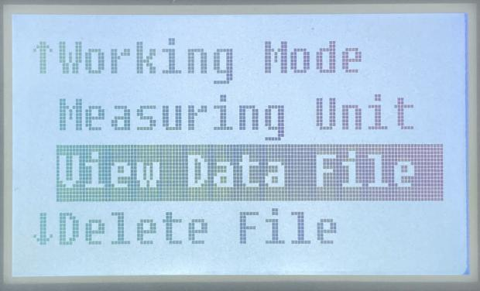  图片文件名：查看数据文件设置 | ●View Data File  View recorded data under corresponding grouping mode  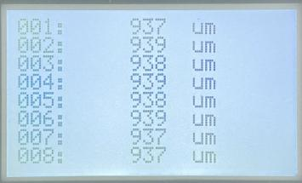  图片文件名：测量结果详情1
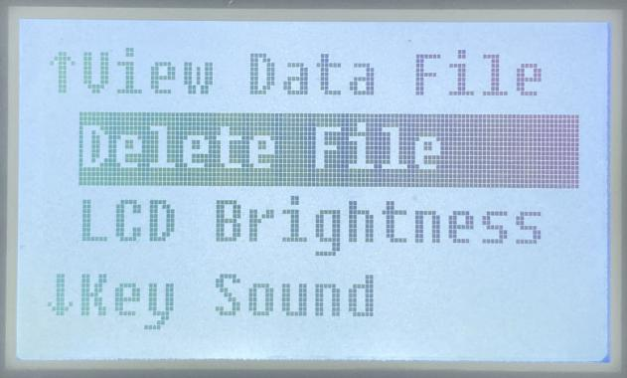  图片文件名：设置删除文件 | ●Delete File  Delete grouped measurement files  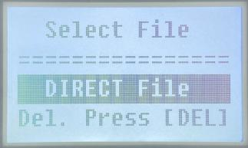  图片文件名：删除文件
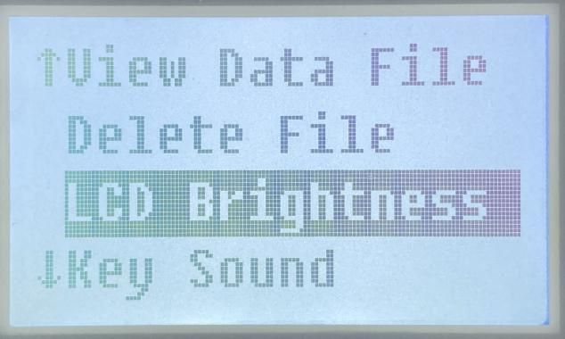  图片文件名：设置屏幕亮度 | ●LCD Brightness  Press the "Up" or "Down" button to adjust the brightness of the display screen.
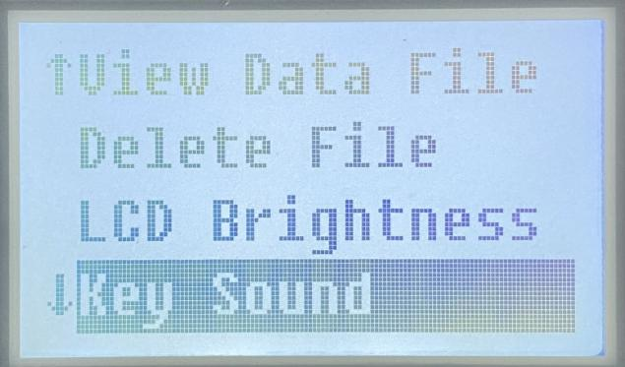  图片文件名：设置按键声音 | ●Key Sound  Choose "ON" or "OFF" to enable or disable the sound of the buttons.
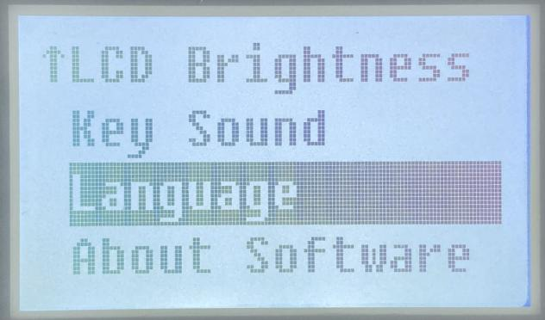  图片文件名：设置语言 | ●Language  Choose between "Chinese" or "English" for language selection.
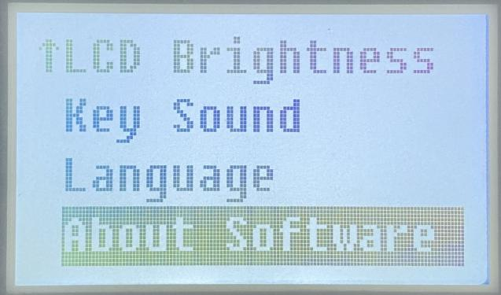  图片文件名：设置软件信息 | ●About Software  This interface allows you to view the software version.

User-friendly
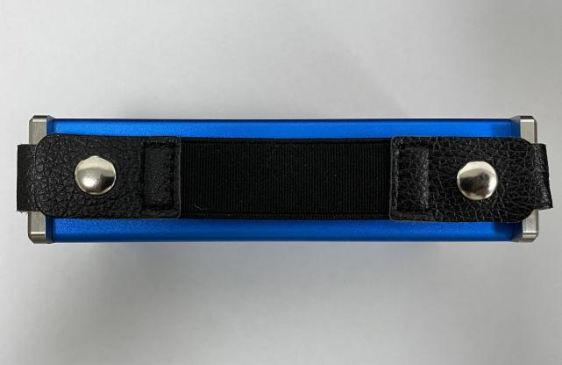  图片文件名：侧面带手箍 | The instrument is equipped with a strap for convenient one-handed use by users and to prevent it from falling.
图片文件名：背面 | The back of the instrument is provided with button indications, facilitating users to view the instrument's button operation instructions.
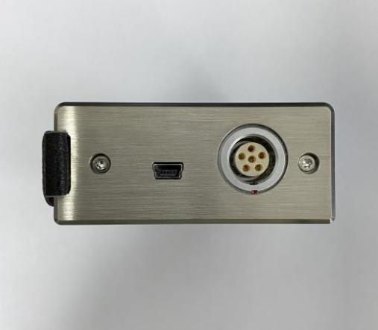  图片文件名：上面接口 | There are red eye-catching marks on the interface direction to guide users to connect the cable correctly.

Operation Process
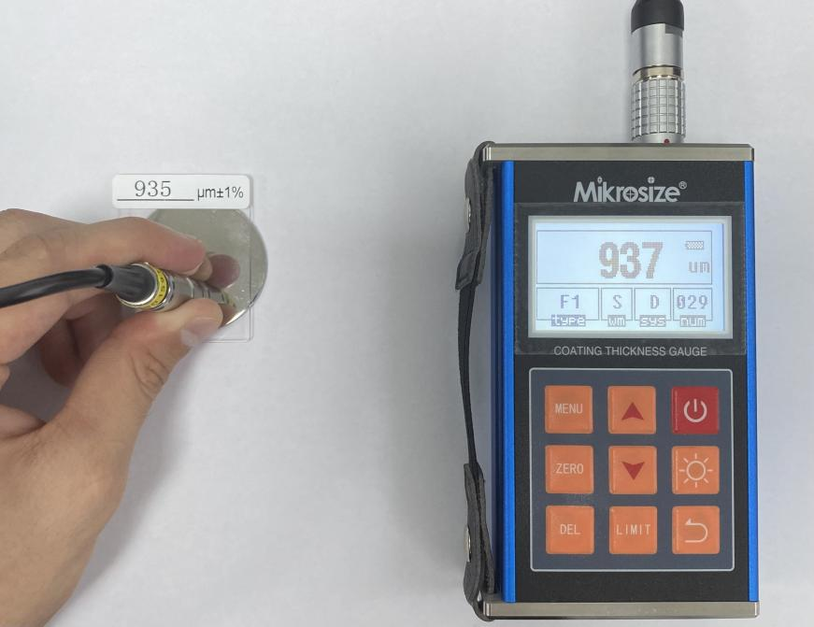
图片文件名：测试过程

Steps of Use:
●Check if the battery is fully charged to prevent insufficient power from affecting the measurement results during the process.
●Wipe the sensor head with a soft cloth or tissue to ensure it is free from dust, oil, and other impurities, thus guaranteeing the accuracy of the measurement.
●After turning on the instrument, perform calibration as needed. Calibration ensures the accuracy of measurement results.
●Determine the specific location where the coating thickness needs to be measured based on your requirements.
●Clean the measurement area with an appropriate cleanser or cloth to ensure the surface is clean and free from impurities, thereby enhancing measurement accuracy.
●Place the sensor head of the coating thickness gauge vertically and steadily on the surface to be tested, ensuring that the sensor is in close contact with the coating surface.
●Gently press the sensor head to trigger the measurement.
●The thickness value of the coating will be displayed on the screen.
The instrument has a fast measurement speed and can quickly display the measurement results. It also has high sensitivity and an accuracy of up to 1/10000mm.

Technical Parameters

Probe Model |  | F1 | F1/90° | F10 | N1
Operating Principle |  | Magnetic |  |  | Eddy current
Substrate Material |  | Magnetic metal (steel, iron etc.) |  |  | Non-magnetic metal substrate  (copper, aluminum, zinc, tin etc.)
Coating Material |  | Non-magnetic coating  (aluminum, chromium, copper, enamel, rubber, paint etc.) |  |  | Non-conductive coating (enamel, rubber, paint, plastic and etc.)
Measuring Range (μm) |  | 0～1250 |  | 0～10000 | 0～1250
Low range Resolution (μm) |  | 0.1 |  | 10 | 0.1
Accuracy | One-point Calibration (μm) | ±(3%H+1) |  | ±(3%H+10) | ±(3%H+1.5)
Accuracy | Two-point Calibration (μm) | ±((1～3)%H+1) |  | ±((1～3)%H+10) | ±[(1～3)%H+1.5]
Measuring Conditions | Min Curvature Radius | 1.5mm | Flatten | 10mm | 3mm
Measuring Conditions | Diameter of the Min Area | Φ7mm | Φ7mm | Φ40mm | Φ5mm
Measuring Conditions | Critical Thickness of Substrate | 0.5mm | 0.5mm | 2mm | 0.3mm
Note: H——Nominal value

Technical Parameters
Operating Environment | Temperature: 0℃~40℃
Operating Environment | Humidity: 20%~90%RH
Operating Environment | No strong magnetic field
Power Supply | 2×1.5V AA (Size 5)
Dimensions | 125mm×70mm×31mm
Weight | About 400g

Standard Delivery
Name | Qty
Main Unit | 1
Probe | 1(F1 or N1) | 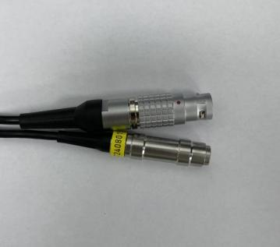  图片文件名：接口
Calibration Foils | 5 PCS | 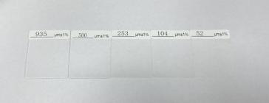  图片文件名：标准片
Zero Plate | 1(Iron or Aluminum) | 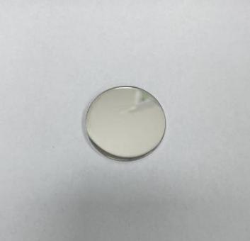  图片文件名：基体
Operating Manual | 1
Warranty Card | 1
Instrument Case | 1

Optional Delivery
F1 (Iron-Based Probe) | 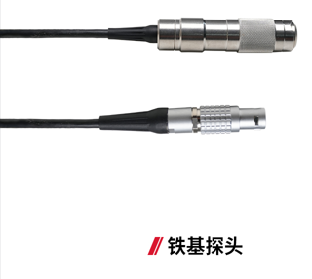  图片文件名就是图片汉字，下同
F1/90° (Right-Angle Probe) | 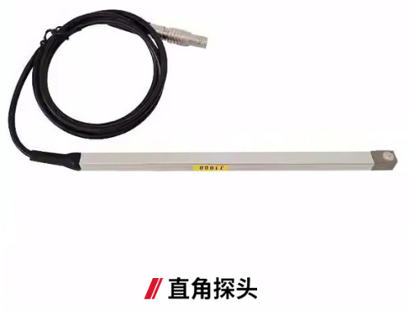
F10 (Large Range Probe) | 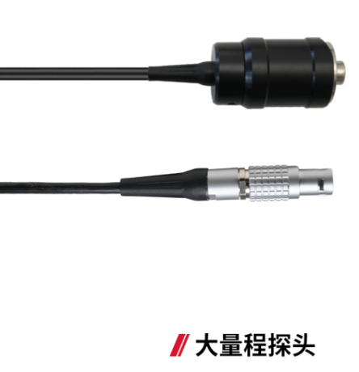
N1 (Aluminum-Based Probe) | 